附件1：
Annex 1
建筑师负责制管理手册大纲
Outline of the Architect Responsibility System Management Manual
- 建筑师负责制
- Architect Responsibility System
“建筑师负责制”是以担任民用建筑工程项目设计主持人或设计总负责人的注册建筑师（以下称为首席建筑师）为核心的设计团队，依托所在的设计企业为实施主体，依据合同约定，对民用建筑工程全过程或部分阶段提供设计咨询管理服务，最终将符合建设单位要求的建筑产品和服务提供给建设单位的一种工作模式。
Architect Responsibility System refers to the work mode under which the design team, with a registered architect (hereinafter referred to as the chief architect) as its core, provides design consulting management services for the whole or part of the process of the civil architectural project and submit the Owner construction products and services which are required by the Owner as stipulated in the contract. Under this model, the chief architect shall be the main project manager or the overall person in charge and the subject of implementation shall be the design agency for which they work for.
本项目首席建筑师负责制贯穿规划优化、方案设计、初步设计、施工图设计、招标采购、施工监管、竣工验收等项目全生命周期。
Architect Responsibility System will run through the whole process of this project, including phases as planning optimization, schematic design, preliminary design, construction drawings design, bidding procurement, construction supervision, and completion acceptance.
- 首席建筑师职责
- The Chief Architect’s Responsibilities
首席建筑师是本项目建筑师负责制的主体，承担建筑师负责制中的各项责任和义务，通过介入项目全生命周期的管理来保证建筑外观效果呈现、功能及造价控制目标的实现。首席建筑师负责主持方案、初步设计阶段的具体设计工作，并参与施工图阶段的设计成果审核和施工阶段涉及建筑观感、功能和造价方面的管理工作，具体工作内容详见《首席建筑师工作内容清单》。
The chief architect, as the main body, shall assume all duties and responsibilities as stipulated in the system. They shall guarantee the realization of such things as the appearances and functions of the building and cost control by involving in the project management life cycle. The chief architect is responsible for the scheme design and concrete design in the conceptual phase. They shall participate in the design work review in the construction drawings design phase and supervise the work involving the appearances and functions of the building and cost in the construction stage. More detailed information is listed in the List of Chief Architect’s Job Description.
- 首席建筑师主要工作清单
- List of Chief Architect’s Main Duties
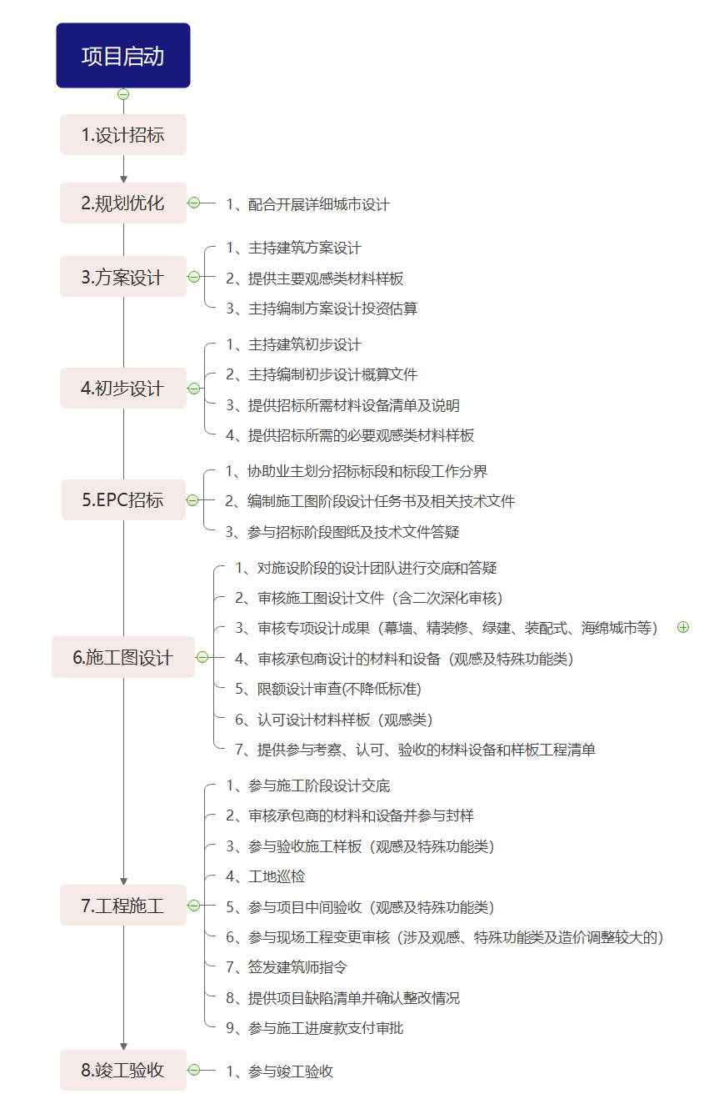
Project Initiation
- Design Bidding
- Conduct detailed urban design
2. Planning Optimization

- Preside over the schematic design
- Provide samples for main impression materials
- Preside over the investment estimate for schematic design
- Schematic Design
- Deliver design results and answer any questions of design teams in construction drawings design process
- Review construction drawings document (include second-time thorough review)
- Review special design results (include items as curtain wall, fine decoration, green design, assembly design, sponge city and others)
- Review materials and equipment designed by the contractor (which are involved in impression part and other parts with special functions)
- Review quota design (standards shall be maintained)
- Approve design material samples (which are involved in impression part and other parts with using functions)
- Produce the list of materials, equipment and typical projects for review, approval and acceptance and
6. Construction Drawings
Design
5. EPC Bid
- Assist the Owner in dividing the bid-sections and setting the boundaries
- Draw up the design assignment book and related technical documents in construction process
- Participate in the Q&A about construction drawings and technical documents in bidding process
- Preliminary Design
- Preside over the preliminary design
- Draw up budget estimate document for preliminary design
- Provide lists and specifications of materials and equipment needed in bidding process
- Provide samples for necessary impression materials needed in bidding process

- Attend design disclosure in construction process
- Check and stamp contractor’s materials and equipment
- Attend the acceptance of sample construction (including impression part and other parts with special functions)
- On-site inspection
- Take part in intermediate acceptance (of impression construction and of other special kinds)
- Review any changes in construction process (of impression parts, parts with special functions and that with major cost adjustment)
- Sign architect’s instructions
- Produce the list of projects flaws and check the rectification
- Examine and approve payment of construction fees

7. Construction

Participate in the completion acceptance
8. completion
acceptance

- 首席建筑师工作内容明细表
- Chief Architect Job Description.
序号 | 首席建筑师工作内容
1 | 参与规划 | 1.1规划优化 | 1、配合主办单位组织开展的详细城市设计，并根据需求提出调整建议。
2 | 设计阶段 | 2.1主持建筑方案设计 | - 主持方案设计，提供设计成果并签字确认  - 主持编制方案设计投资估算，提供成果文件并签字确认  - 提供建筑主要观感类材料样板
 |  | 2.2主持建筑初步设计 | 1、主持初步设计，提供初步设计成果并签字确认  2、主持编制初步设计概算，提供成果文件并签字确认  3、提供招标所需涉及观感、档次、特殊功能要求及对造价影响较大的材料设备清单及说明  4、提供招标所需的必要观感类材料样板
 |  | 2.3审核施工图设计成果（含二次深化审核） | 1、对施工图设计阶段的设计团队进行交底和答疑  2、审核施工图设计成果（含二次深化审核），确认其是否满足方案、初设意图，重点审核其使用功能、安全、环保、节能、观感等是否符合要求，确认造价控制是否满足初步设计概算要求  3、审核承包商设计的材料和设备（观感及特殊功能类）  4、认可设计材料样板（涉及观感、使用功能）  5、提供书面成果确认单  6、首席建筑师主要负责把控观感效果、使用功能、标准档次及造价控制，不对施设阶段成果中的专业技术内容负责
 |  | 2.4审核各专项设计成果（包含景观、幕墙、灯光、场地、精装修、软装及工艺品配置、标识设计等） | - 对设计团队进行交底和答疑  2、对专项设计各阶段成果进行审核，重点审核其使用功能、建筑观感效果呈现、档次等是否符合建筑方案要求、是否满足造价控制要求  3、对主要材料选型及样板进行确认  4、提供书面成果确认单  5、首席建筑师主要负责把控观感效果、使用功能、档次标准及造价控制，不对施设阶段成果中的专业技术内容负责
 |  | 2.5审核其他特殊工艺设计 （如有） | - 对特殊工艺设计（如有）进行交底和答疑  2、对工艺设计的最终成果进行审核，重点审核其使用功能、建筑观感效果呈现等是否符合建筑方案要求，判断工艺方案的合理性，确认是否满足造价控制要求  3、提供书面成果确认单  4、首席建筑师主要负责把控观感效果、使用功能及造价控制，不对施设阶段成果中的专业技术内容负责
 |  | 2.6 BIM专项设计 | - 提供满足报审要求（初步设计阶段）的BIM模型及相关材料，对下一阶段（施工图阶段）BIM深化进行交底和答疑  - 对施工图及施工阶段的BIM模型进行审核，重点审核其使用功能、建筑观感效果呈现等是否符合建筑方案要求  3、参与施工图阶段BIM模型验收，对模型外观、碰撞分析结果、模拟建造情况进行确认  4、参与BIM建造、运营管理平台搭建
 |  | 2.7绿色建筑、装配式建筑、海绵城市，智能化、环保等 | 1、提供绿色建筑、装配式建筑、海绵城市，智能化、环保等初步设计阶段专项设计，满足政府审批要求  2、对施工图阶段设计团队进行上阶段专项设计交底，并对各专项设计最终成果进行审核确认，重点审核其使用功能、建筑观感效果呈现等是否符合建筑方案及上阶段设计要求，确认是否满足造价控制要求  3、提供书面成果确认单  4、首席建筑师主要负责把控观感效果、使用功能及造价控制，不对施设阶段成果中的专业技术内容负责
 |  | 2.8审核人防工程 | - 对人防工程在各子项可能存在的专项设计进行答疑  - 对人防专项设计最终成果进行签字确认，确认是否满足方案及造价控制要求  - 提供书面成果确认单  4、首席建筑师主要负责把控观感效果、使用功能及造价控制，不对施设阶段成果中的专业技术内容负责
 |  | 2.9限额设计审查(不降低标准) | - 主持方案、初步设计阶段限额设计，确保初步设计概算不超可研批复金额  - 施工图阶段加强造价审核，使施工图预算费用及施工结算费用控制在概算范围内，同时不得降低设计标准和更改使用功能
 |  | 2.10提供参与材料考察、样板验收清单 | 在施工图设计阶段提供《需实地考察的材料设备清单》、《需提供样板的设计材料清单》、《需总建筑师参与验收的样板工程清单》及《涉及观感、特殊功能要求及对造价影响较大的材料设备清单》
3 | 承包商招投标阶段 | 3.1参与划分招投标界面 | 1、协助业主进行招标标段划分，参与讨论各标段工作分界面
 |  | 3.2协助业主完善招标文件 | 1、提供招标图纸及相关文件  2、编制施工图阶段设计任务书  3、提供招标所需涉及观感、档次、特殊功能要求及对造价影响较大的材料设备清单及说明  4、提供招标所需的必要材料样板
 |  | 3.3参加技术答疑 | 1、对招标技术文件进行说明及答疑
4 | 施工阶段 | 4.1参与施工阶段设计交底 | 1、参加建设单位组织的施工图设计交底和图纸会审并发表意见，阐明设计意图，并对承包商及监理单位等提出的问题进行答疑与说明，设计交底由施工图阶段建筑师负责
 |  | 4.2审核承包商的材料和设备并参与涉及观感类材料封样 | 1、参与考察涉及观感类相关的材料、设备，提出意见或建议  2、承包商进行采购前将涉及观感类相关的材料、设备报首席建筑师签字确认并封样
 |  | 4.3验收施工样板 | - 参与涉及观感的样板工程验收并提出意见  - 参与样板验收会议纪要签字
 |  | 4.4工地巡检 | 1、派驻现场代表  2、出席工地例会及参与必要的（由建设单位通知）现场会议  3、定期及不定期巡检，重点检查工程实体与设计意图的符合性  4、在建造期间对发现的问题及时要求承包商整改
 |  | 4.5参与项目中间验收 | - 参与现场涉及观感类验收并提出意见  - 参与中间验收会议纪要签字
 |  | 4.6参与工程变更审核 | - 参与现场工程变更审核（涉及观感、特殊功能类及造价调整较大的），并向建设单位出具审核意见
 |  | 4.7建筑师指令 | 1、首席建筑师在发现现场施工情况与原方案、初步设计意图不符、或现场确有变更必要时，可签发首席建筑师指令单  2、首席建筑师原则上只能签发与建筑观感效果、使用功能、标准档次有关的指令单
 |  | 4.8提供项目缺陷清单 | 1、建设基本完成时，建筑师全面检查实体工程，并提供项目缺陷清单供施工单位整改  2、建筑师对项目缺陷清单的整改结果进行确认
 |  | 4.9参与施工进度款支付审批 | - 审查签认材料设备以及工程进度、工程款支付确认单，监督工程建设项目按照设计文件要求进行实施
5 | 竣工验收阶段 | 5.1竣工验收 | 1、参与竣工验收并发表验收意见

No. | Chief Architect Job Description
1 | The planning phase | 1.1 Planning Optimization | 1. Make reasonable suggestions based on the detailed urban design conducted by the organizer.
2 | The design phase | 2.1Take charge of the construction schematic design | 1. Take charge of the schematic design, provide final results and sign for confirmation.  2. Estimate the investment of the construction design, provide the final document with signature confirmation  3. Provide samples for main impression materials.
 |  | 2.2 Take charge of the preliminary design | 1. Preside over the preliminary design, submit results and sign for confirmation  2. Take charge of budget estimate for preliminary design and provide the final document with signature confirmation.  3. Provide lists and specifications for materials and equipment required in the bidding process which involve the impression, grade and special functional requirements and have a great impact on cost.  4. Provide samples for necessary impression materials needed in bidding process.
 |  | 2.3 Review construction drawings document (include second-time in-depth review) | 1. Make construction disclosure and answer any questions of design teams in construction drawings design process  2. Review construction drawings (include second-time in-depth review). Verify whether the design matches with the schematic and initial purpose with focusing on whether the using functions, safety, eco-friendly design, energy conservation and impressions meet requirements. Verify whether the cost control meet the demand of the preliminary design budget estimate.  3. Review materials and equipment designed by the contractor (which are involved in impression part and other parts with special functions)  4. Approve design material samples (which are related to impression part and other parts with using functions)  5. Provide written confirmation of the results.  6. The chief architect shall take charge of the work which is related to the impression, using functions, level of standards and cost control. But they are irresponsible for technical tasks in the construction design phase.
 |  | 2.4Review special design results (including items as landscape, curtain wall, lights, venues, fine decoration, soft decoration, handiwork decoration, sign design and others) | 1.Make disclosure and answer  questions of the design team.  2. Review the results produced in special design phases. Verify whether the using functions, impressions and levels meet the requirements of the scheme and limits of the cost control.  3. Verify the main material selections and samples.  4. Provide written confirmation of the results.  5. The chief architect shall take charge of the work which is related to the impression, using functions, level of standards and cost control. But they are irresponsible for technical tasks in the construction design phase.
 |  | 2.5 Review other special process designs (if needed) | 1. Brief the special process design clearly and thoroughly and answer related questions.  2. Review the results of process designs. Verify whether the using functions and impressions meet the requirements of the scheme and limits of the cost control and whether they are reasonable.  3. Provide written confirmation of the results.  4. The chief architect shall take charge of the work which is related to the impression, using functions, level of standards and cost control. But they are irresponsible for technical tasks in the construction design phase.
 |  | 2.6 BIM design | 1. Provide the BIM model and relevant materials which meet application requirements (initial design phase) and deliver revised BIM design required in the next phase (construction drawings design) and answer related questions.  2. Review the BIM model given in the construction drawings and in the construction process, focusing on whether the using functions and impressions meet the requirements of the scheme.  3. Take part in the completion acceptance of the BIM model in the construction drawing design phase. Check the appearance, collision analysis and simulation construction of the model.  4. Participate in BIM construction and the establishment of operational platforms.
 |  | 2.7Responsibilities related to environment-friendly buildings, fabricated buildings, sponge city, intelligent application and environmental protection | 1. Provide specialized design for environment-friendly buildings, fabricated buildings, sponge city, intelligent application and environmental protection in the preliminary design phase for administrative approval.  2. Deliver specialized design to design teams work in the construction drawings design phase and verify the results with focusing on whether the using functions and construction impressions meet the requirements of the scheme and of the cost control plan.  3. Provide written confirmation of the results.  4. The chief architect shall take charge of the work which is related to the impression, using functions, level of standards and cost control. But they are irresponsible for technical tasks in the construction design phase.
 |  | 2.8 Verify civil air-defense engineering | 1. Answer relevant questions about possible the specialized designs of sub-items in civil air-defense engineering.  2. Check the results of specialized design of civil air-defense engineering and sign for confirmation.  3. Provide written confirmation of the results.  4. The chief architect shall take charge of the work which is related to the impression, using functions, level of standards and cost control. But they are irresponsible for technical tasks in the construction design phase.
 |  | 2.9 Review quota design (standards shall be maintained) | 1. Take charge of the quota design in phases of scheme design and preliminary design. Make sure the initial design cost is lower than that requested.  2. Strengthen engineering cost audit in the construction drawings design phase. Keep the estimated and closing costs lower than the budget with design standards and using functions unchanged.
 |  | 2.10 Provide the list of materials, equipment and samples that are required to be checked. | 1. Produce “the list of materials and equipment that need on-site inspection”, “the list of design materials that need to provide samples”, “the list of model projects that require the chief architect to participate in acceptance” and “the list of materials and equipment which involve impressions, special functional requirements and have a great impact on the construction cost”.
3 | Construction Bidding Phase | 3.1 Participate in dividing bid interface | 1. Assist the Owner in dividing the bid-sections and participate in the discussion about dividing the bidding interface
 |  | 3.2 Assist the Owner in improving bidding documents | 1. Produce bidding drawings and related documents.  2. Draw up the design assignment book for the construction drawings phase.  3. Provide lists and specifications for materials and equipment required in the bidding process which involve the impression, grade and special functional requirements and have a great impact on cost.  4. Provide necessary material samples required in the bidding process.
 |  | 3.3 Participate in the Q&A session about technical parts. | 1. Give instructions and answer related questions about bidding technical documents.
4 | Construction Phase | 4.1 Attend design disclosure in the construction phase | 1. Attend design disclosure and drawings review organized by the construction unit and give comments. Expound the design idea and answer the questions given by the contractor and supervising unit. Architects in the construction drawings design phase are responsible for design disclosure.
 |  | 4.2 Check the materials and equipment offered by the contractor and seal impression materials samples | 1. Review impression materials and equipment. Bring forward any opinions and suggestions.  2. The contractor shall inform the chief architect of impression materials and equipment and the latter shall sign for confirmation and seal samples.
 |  | 4.3 Check and accept construction samples | 1. Check and accept construction samples which involve architectural impression and make suggestions.  2. Sign in the acceptance meeting minutes.
 |  | 4.4 On-site inspection | 1. Station representatives to the construction site.  2. Attend on-site regular meetings and other essential meetings (informed by the construction unit)  3. Pay regular or non-scheduled visits with focusing on whether the construction goes well as designed.  4. Ask the contractor to rectify defects discovered during the construction.
 |  | 4.5 Take part in intermediate acceptance | 1. Check and accept the impression construction and make suggestions.  2. Sign in the intermediate acceptance meeting minutes.
 |  | 4.6 Participate in change review | 1. Review any changes in the construction process (of impression parts, parts with special functions and that with major cost adjustment) and make audit opinions for the construction unit.
 |  | 4.7 Architect’s instructions | 1. The chief architect shall sign and issue the architect’s instructions when the construction site situation is inconsistent with the original scheme and the preliminary design intention or when any change is necessary.  2. In principle, the chief architect can only sign and issue instructions that are related with impressions, using functions and grades.
 |  | 4.8 Produce the list of project flaws | 1. Inspects the physical project， produce the list of project flaws for rectification when the construction is basically completed.  2. Verify the rectification.
 |  | 4.9 Examine and approve payment of construction fees | 1. Check materials and equipment, project process and payment confirmation sheet. Supervise whether the construction is consistent with design documents.
5 | Completion acceptance | 5.1 Completion acceptance | 1. Participate in the completion acceptance and make suggestions.

